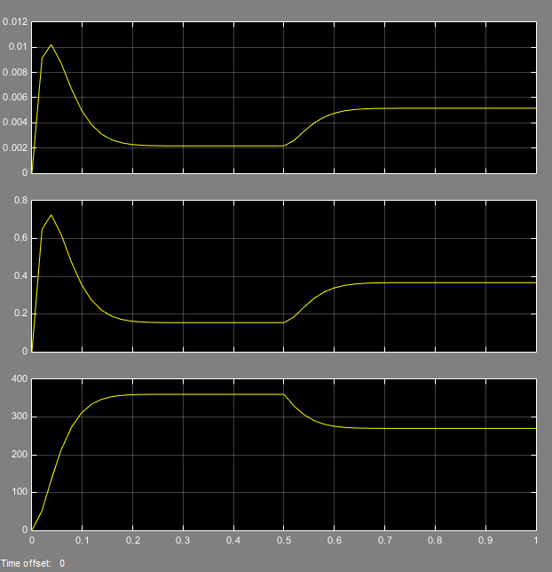

Figure : Permanent Magnet DC Motor Transient Response

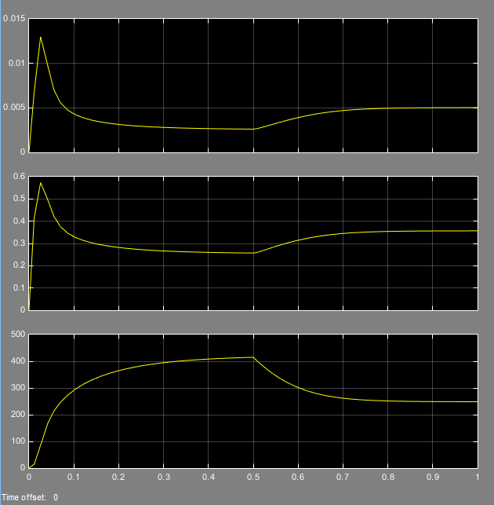

Figure : Series DC Motor Transient Response